FitTrack
Fitness Tracking Mobile Application
UX/UI Design Documentation & Case Study

Role: Lead UX/UI Designer
Design Tool: Figma
Task : 1

1. Project Overview
Project Name
FitTrack – Personal Fitness Companion
Project Type
Mobile Fitness Tracking Application

Purpose
FitTrack is a fitness and wellness application designed to help users monitor their daily physical activities, track workouts, manage fitness goals, and maintain a healthy lifestyle through personalized insights and progress monitoring.

Target Audience
- Fitness enthusiasts
- Students and young professionals
- Gym beginners
- Health-conscious individuals
- People aiming for weight loss or muscle gain

2. Problem Statement
Many people struggle to maintain consistency in their fitness journey because they lack:
- A centralized fitness tracking system
- Daily motivation and reminders
- Clear visualization of progress
- Personalized workout recommendations
- Goal tracking mechanisms

FitTrack addresses these challenges by providing a simple and engaging fitness management experience.

3. Objectives
The primary objectives of FitTrack are:
Health Monitoring
Track daily activities and fitness metrics.
Workout Management
Provide categorized workout programs.
Goal Achievement
Allow users to set and monitor personal fitness goals.
Motivation
Encourage consistency through challenges and progress tracking.
User-Friendly Experience
Deliver a clean, modern, and intuitive interface.

4. Design Process
Step 1: User Research
Common findings:
User Need | Observation
Easy Tracking | Users want quick access to daily statistics
Motivation | Users enjoy challenges and achievements
Progress Visualization | Graphs help users stay motivated
Goal Setting | Users prefer measurable goals

Step 2: User Persona
Persona: Priya
Age: 22
Occupation: Student
Goals
- Lose weight
- Improve fitness level
- Maintain workout consistency
- Forgets workouts
- Lacks motivation
- Doesn't track progress regularly

5. Information Architecture

Splash Screen
│
▼
Login Screen
│
▼
Home Dashboard
│
┌────┼────┬─────┐
▼ ▼ ▼ ▼
Home Workout Goals Profile

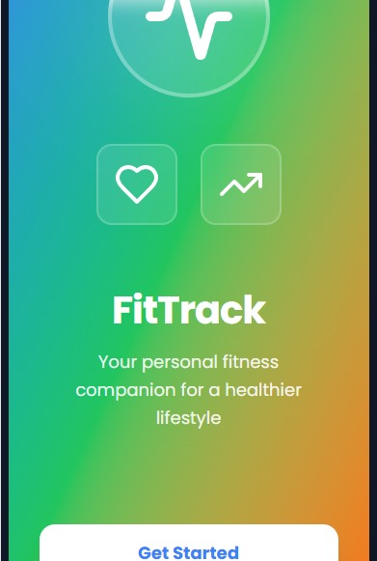

6. Screen Analysis

Screen 1: Splash Screen
Purpose
Creates the first impression of the application.
Features
- App logo
- Fitness-related icons
- Application name
- Call-to-action button
Design Highlights
- Gradient background
- Minimalistic layout
- Modern typography
User Action
Click Get Started

Screen 2: Login Screen
Purpose
Authenticate users securely.
Components
Email Field
User enters registered email.
Password Field
Secure password input.
Sign In Button
Allows account access.
Social Login
- Google Login
- Apple Login
Sign Up Link
Creates a new account.
Benefits
- Fast authentication
- Multiple login options
- User-friendly interface

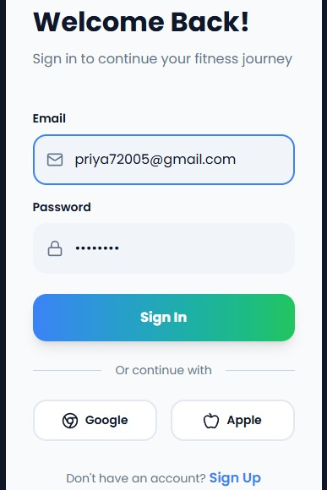

Screen 3: Home Dashboard
Purpose
Provide an overview of daily fitness performance.
Features
Daily Steps
- 10,547 steps
- 70% goal completion
Calories Burned
- 487 kcal
Water Intake
- 6/8 glasses completed
Weekly Progress Graph
Visual representation of activity levels.
Benefits
- Quick performance review
- Progress monitoring
- Daily motivation

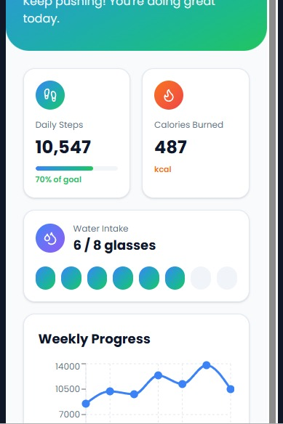

Screen 4: Weekly Progress
Purpose
Analyze workout performance.
Graph Metrics
- Monday to Sunday activity tracking
- Peak performance identification
- Trend analysis

Advantages
- Data-driven fitness decisions
- Improved consistency

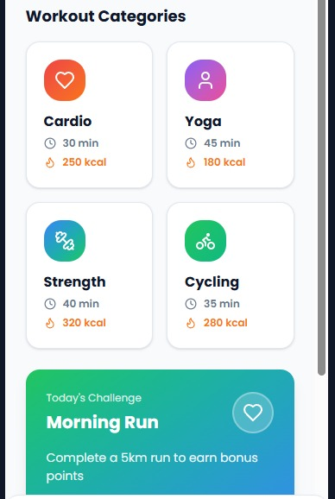

Screen 5: Workout Categories
Available Workouts
Cardio
- Duration: 30 min
- Calories: 250 kcal
Yoga
- Duration: 45 min
- Calories: 180 kcal
Strength Training
- Duration: 40 min
- Calories: 320 kcal
Cycling
- Duration: 35 min
- Calories: 280 kcal
Benefits
- Workout variety
- Easy selection
- Personalized fitness routines

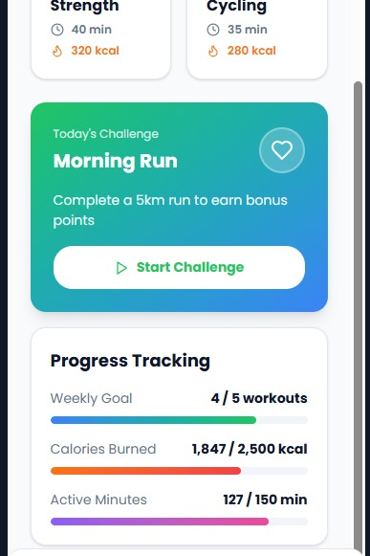

Screen 6: Daily Challenge
Challenge Name
Morning Run
Objective
Complete a 5 km run.
Reward
Earn bonus points.

Benefits
- Increased motivation
- Daily engagement
- Achievement system

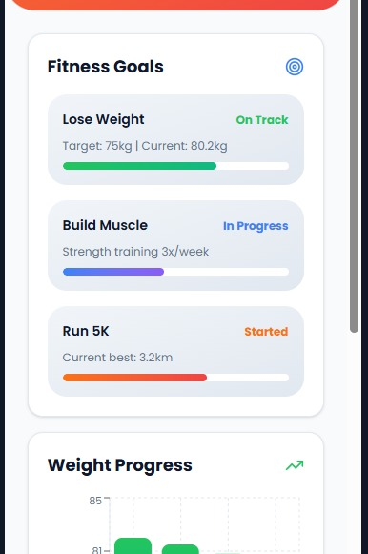

Screen 7: Progress Tracking
Weekly Goal
4/5 workouts completed.
Calories Burned
1,847 / 2,500 kcal
Active Minutes
127 / 150 minutes
Benefits
- Goal visibility
- Performance measurement
- Accountability

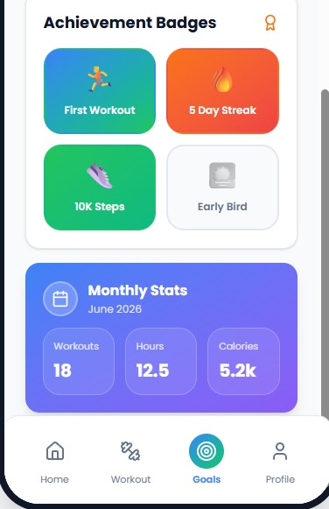

Screen 8: Fitness Goals

Goal 1: Lose Weight
Target Weight:
- 75 kg
Current Weight:
- 80.2 kg
Status:
- On Track

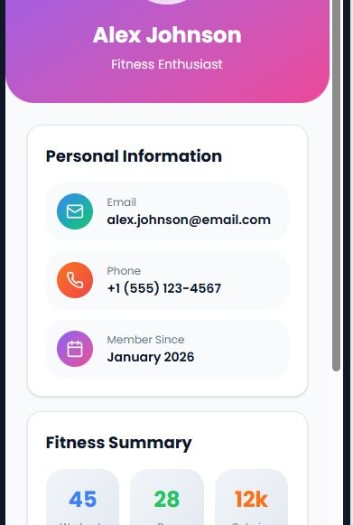

Goal 2: Build Muscle
Target:
- Strength Training 3 Times/Week
Status:
- In Progress

Goal 3: Run 5K
Current Best:
- 3.2 km
Status:
- Started



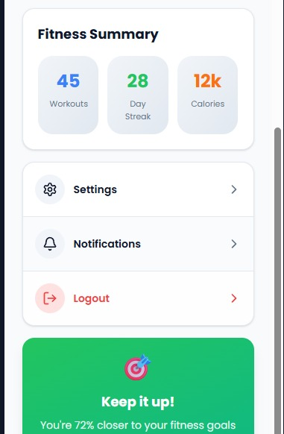

7. Visual Design System

Color Palette
Primary Gradient
#3B82F6
#22C55E
Secondary Colors
Orange: #F97316
Purple: #A855F7
Blue: #2563EB
Green: #22C55E
Gray: #F1F5F9

Typography

Headings
Font:
Poppins Bold
Size:
- 24px – 32px

Subheadings
Font:
Poppins SemiBold
Size:
- 18px – 22px

Body Text
Font:
Poppins Regular
Size:
- 14px – 16px

8. Navigation Structure
Bottom Navigation Menu
Home
Dashboard overview
Workout
Workout categories and challenges
Goals
Goal management
Profile
User account settings

9. Key Features
Fitness Tracking
Track steps, calories, and activity.
Water Intake Monitoring
Daily hydration management.
Workout Library
Various fitness categories.
Goal Management
Set and achieve personal goals.
Progress Analytics
Charts and visual reports.
Daily Challenges
Increase engagement and motivation.
Social Login
Google and Apple integration.

10. Usability Principles Applied
Simplicity
Clean interface with minimal distractions.
Consistency
Uniform colors, typography, and components.
Visibility
Important statistics displayed prominently.
Feedback
Progress bars and completion indicators.
Accessibility
Readable text and intuitive navigation.

11. Future Enhancements
AI Fitness Coach
Personalized workout suggestions.
Smartwatch Integration
Sync with wearable devices.
Nutrition Tracking
Meal and calorie logging.
Community Features
Fitness groups and leaderboards.
Push Notifications
Workout reminders and achievements.

12. Conclusion
FitTrack is a modern fitness-tracking mobile application designed to help users maintain a healthy lifestyle through activity monitoring, workout planning, goal tracking, hydration management, and progress visualization. The intuitive UI, engaging challenges, and data-driven insights create an enjoyable user experience that motivates users to stay consistent and achieve their fitness goals.
TaskFlow AI

Task : 2
Category: AI-Powered Productivity Platform

Project Overview
TaskFlow AI is a modern productivity and workflow management platform that uses Artificial Intelligence to help teams organize tasks, automate repetitive work, improve collaboration, and track performance. The platform is designed to increase productivity through intelligent automation and data-driven insights.

Project Objective
The primary objective of TaskFlow AI is to simplify task management and improve team efficiency by providing AI-powered tools that automate workflows and streamline collaboration.

Problem Statement
Many organizations struggle with:
- Manual task management
- Poor team coordination
- Time-consuming repetitive processes
- Lack of productivity tracking
- Difficulty managing projects across multiple teams
These challenges often result in reduced efficiency and missed deadlines.

Proposed Solution
TaskFlow AI provides an intelligent workspace where teams can:
- Automate routine tasks
- Collaborate in real time
- Monitor project progress
- Access cloud-based resources
- Generate analytics and insights
The platform helps users work smarter while reducing manual effort.

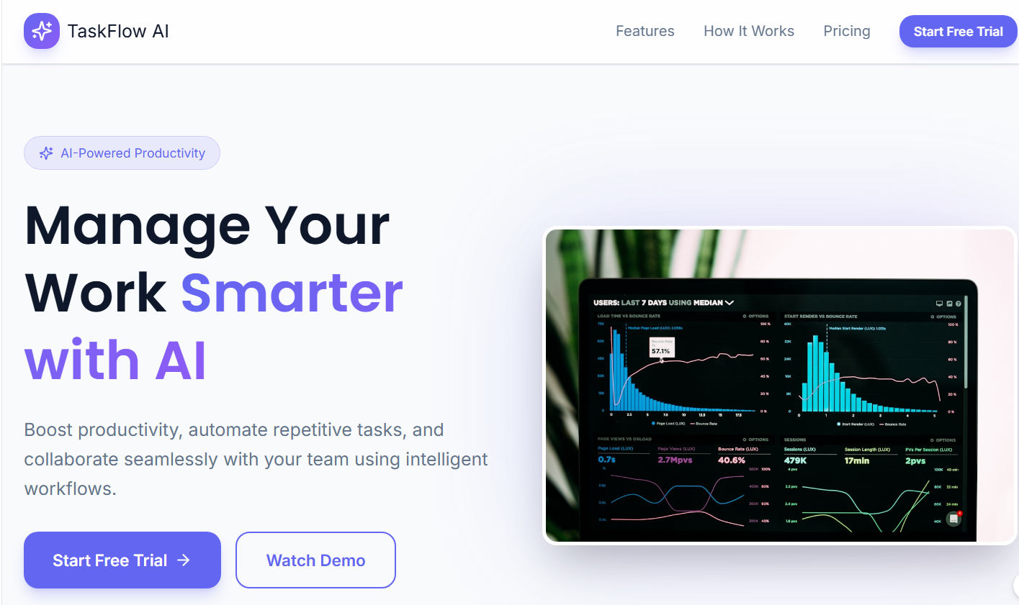

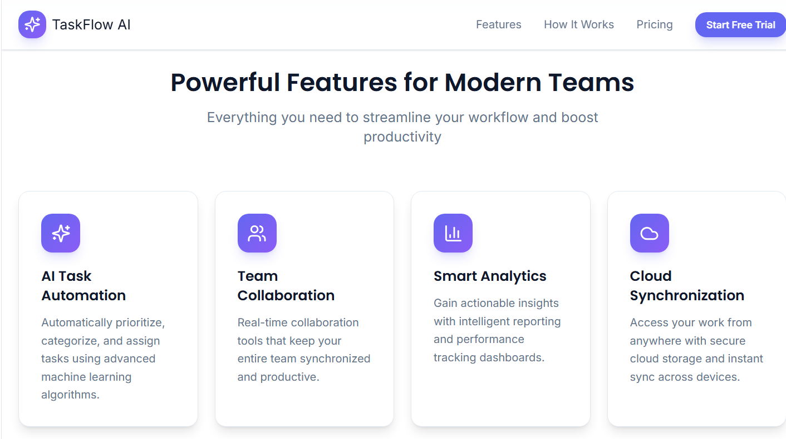Key Features
1. AI Task Automation
- Automatically prioritizes tasks
- Categorizes work items
- Assigns tasks using AI algorithms
- Reduces manual workload
2. Team Collaboration
- Real-time communication
- Shared workspaces
- Team synchronization
- Improved coordination
3. Smart Analytics
- Performance tracking
- Productivity reports
- Actionable insights
- Data visualization dashboards
4. Cloud Synchronization
- Secure cloud storage
- Access from multiple devices
- Automatic data synchronization
- Remote work support

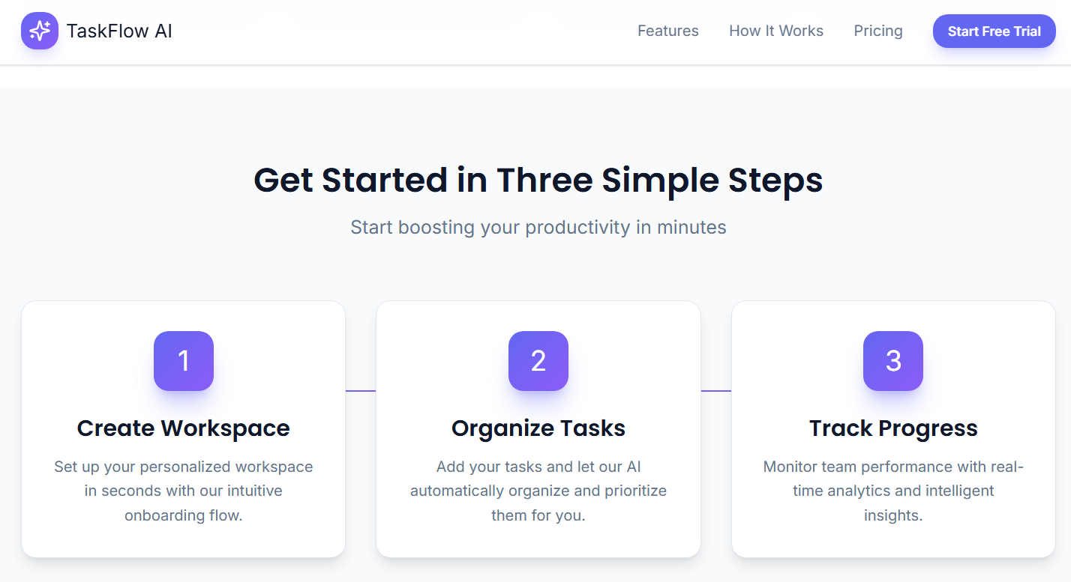

How It Works

Step 1: Create Workspace
Users create a personalized workspace and configure their project settings.
Step 2: Organize Tasks
Tasks are added to the platform, and AI automatically prioritizes and organizes them.
Step 3: Track Progress
Users monitor project status, team performance, and productivity through real-time analytics.

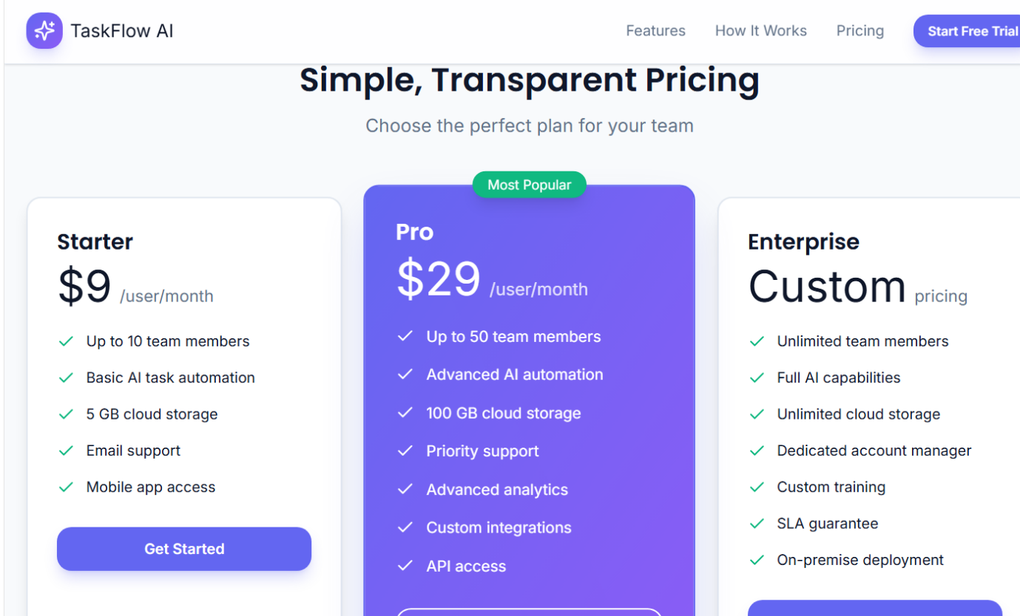

Pricing Plans
Starter Plan – $9/User/Month
- Up to 10 team members
- Basic AI automation
- 5 GB cloud storage
- Email support
- Mobile app access
Pro Plan – $29/User/Month
- Up to 50 team members
- Advanced AI automation
- 100 GB cloud storage
- Priority support
- Advanced analytics
- API access

Enterprise Plan – Custom Pricing
- Unlimited team members
- Full AI capabilities
- Unlimited cloud storage
- Dedicated account manager
- Custom training
- SLA support
- On-premise deployment

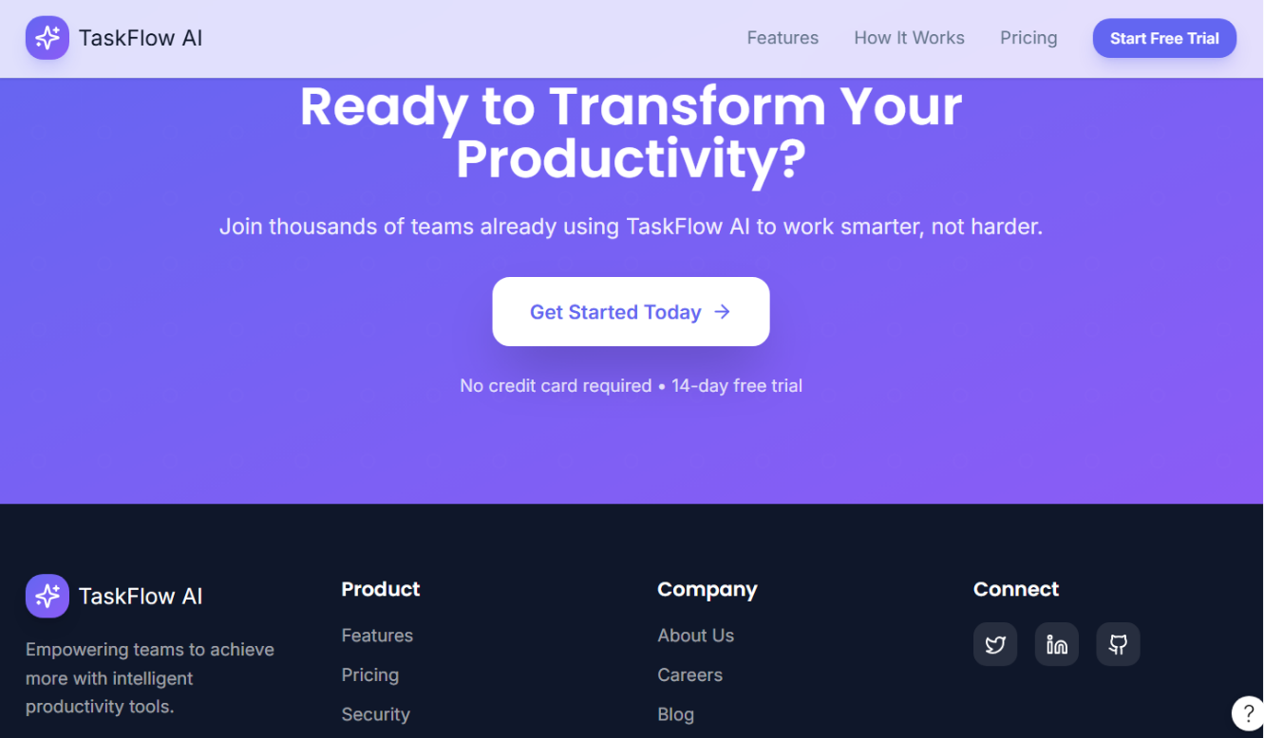

Benefits
- Increased productivity
- Reduced manual work
- Better project visibility
- Improved team collaboration
- Faster decision-making
- Scalable for businesses of all sizes

Expected Outcomes
By implementing TaskFlow AI, organizations can:
- Complete projects faster
- Improve team performance
- Increase operational efficiency
- Enhance collaboration
- Make data-driven decisions

Conclusion
TaskFlow AI is a comprehensive productivity solution that combines artificial intelligence, collaboration tools, analytics, and cloud technology into a single platform. It enables teams to work more efficiently, automate routine tasks, and achieve better business outcomes through smarter workflow management.

FashionHub

Premium Design System
Task : 3

Project Overview
FashionHub is a premium design system created specifically for fashion e-commerce platforms. It provides a complete collection of design foundations, reusable UI components, design tokens, and accessibility guidelines to help designers and developers build consistent, scalable, and visually appealing digital experiences.
The system focuses on luxury aesthetics, usability, and maintainability while ensuring a unified design language across all products.

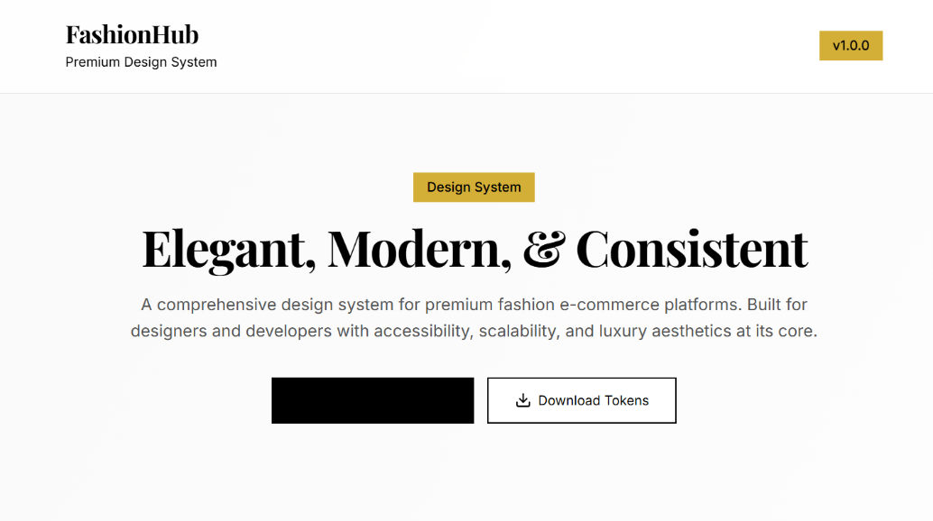

Project Objective
The primary objective of FashionHub is to establish a centralized design framework that enables teams to create high-quality fashion e-commerce applications efficiently and consistently.
Key Goals
- Ensure visual consistency across platforms
- Improve development efficiency
- Enhance user experience
- Support accessibility standards
- Provide reusable design assets
- Simplify design-to-development handoff

System Overview
FashionHub Design System includes:
- 80+ Design Tokens
- 25+ Reusable Components
- WCAG Accessibility Compliance
- Multiple Export Formats
- Comprehensive Documentation
- Scalable Design Foundations
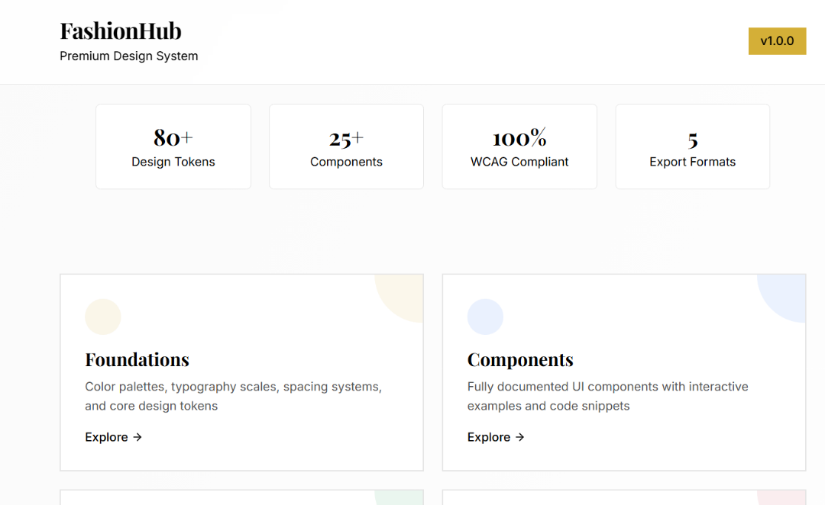

Core Modules
1. Foundations
The Foundations module defines the core visual language of the design system.
Color System
A carefully designed color palette ensures consistency and accessibility.
Primary Colors
Used for:
- Main actions
- Brand identity
- Important content

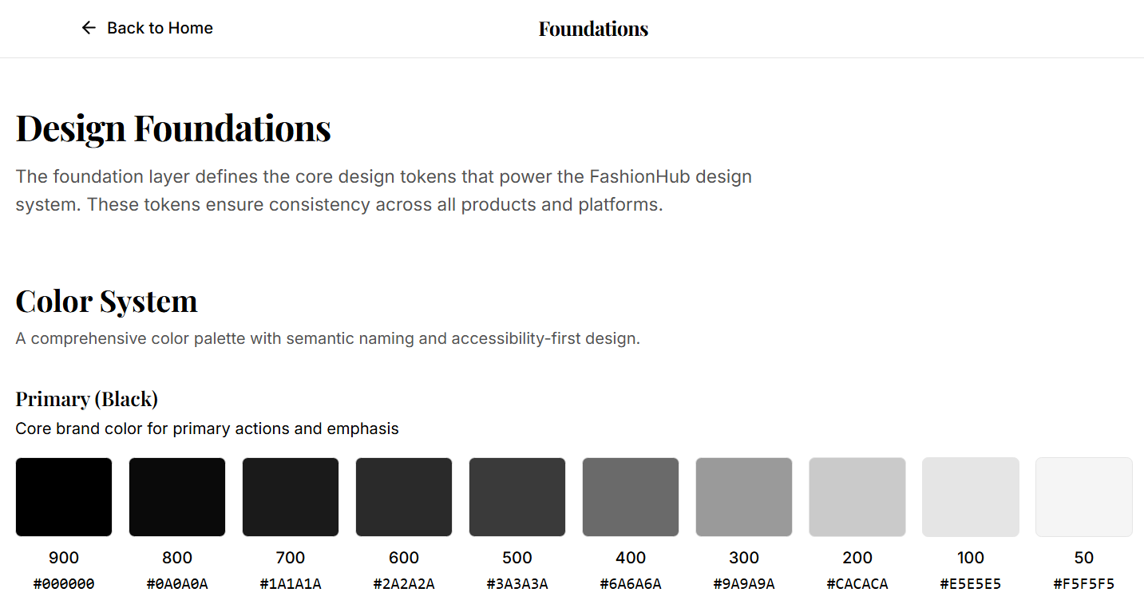

Neutral Colors
Used for:
- Backgrounds
- Borders
- Secondary content
- Layout structure
Accent Gold Colors
Used for:
- Premium experiences
- Promotional banners
- Luxury highlights
Success Colors
Used for:
- Confirmation messages
- Positive actions
- Status indicators

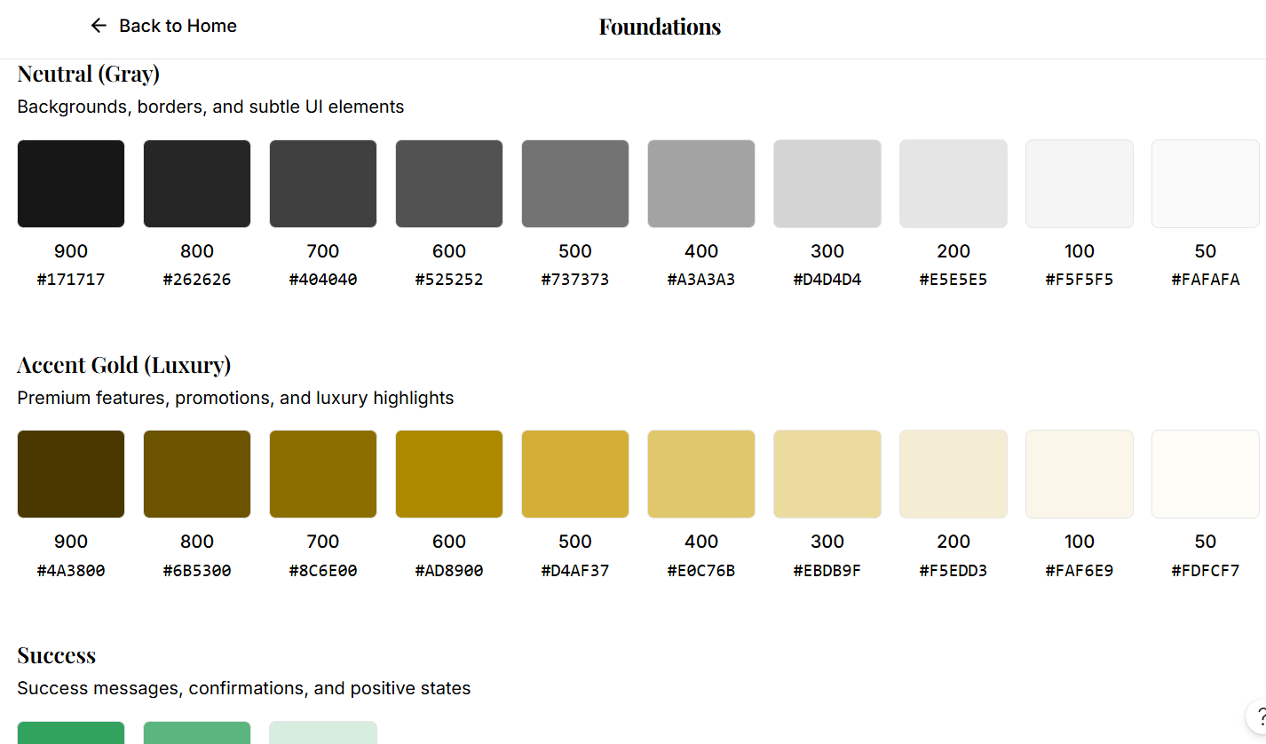

Typography System
FashionHub uses two primary typefaces:
Playfair Display
Used for:
- Hero sections
- Page titles
- Premium branding
- Luxury presentation
Inter
Used for:
- Body content
- Product descriptions
- Forms and navigation
- UI elements

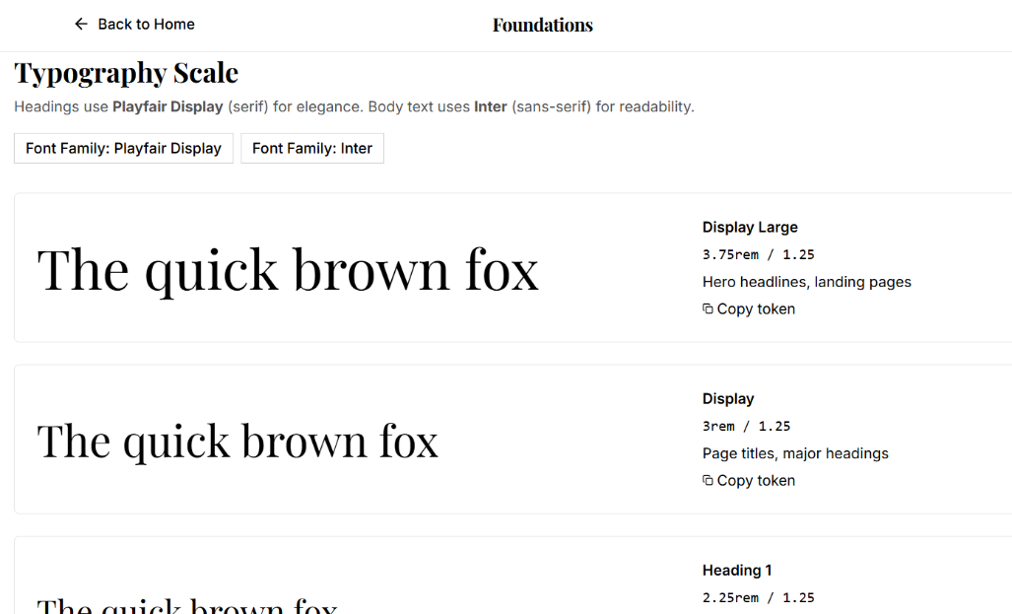
Typography Scale
The system includes:
- Display Large
- Display
- Heading 1
- Heading 2
- Heading 3
- Body Large
- Body Medium
- Body Small
This ensures consistent text hierarchy across all interfaces.

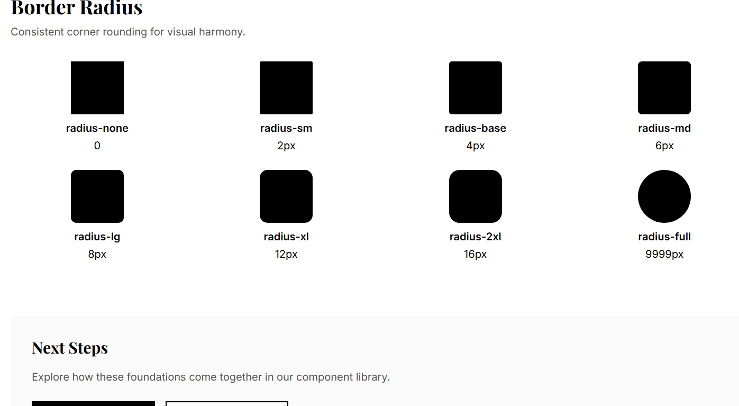
Border Radius System
A standardized radius scale creates visual consistency.
Available values include:
- Radius None
- Radius Small
- Radius Base
- Radius Medium
- Radius Large
- Radius XL
- Radius 2XL
- Radius Full
These values are applied across buttons, cards, inputs, and product containers.
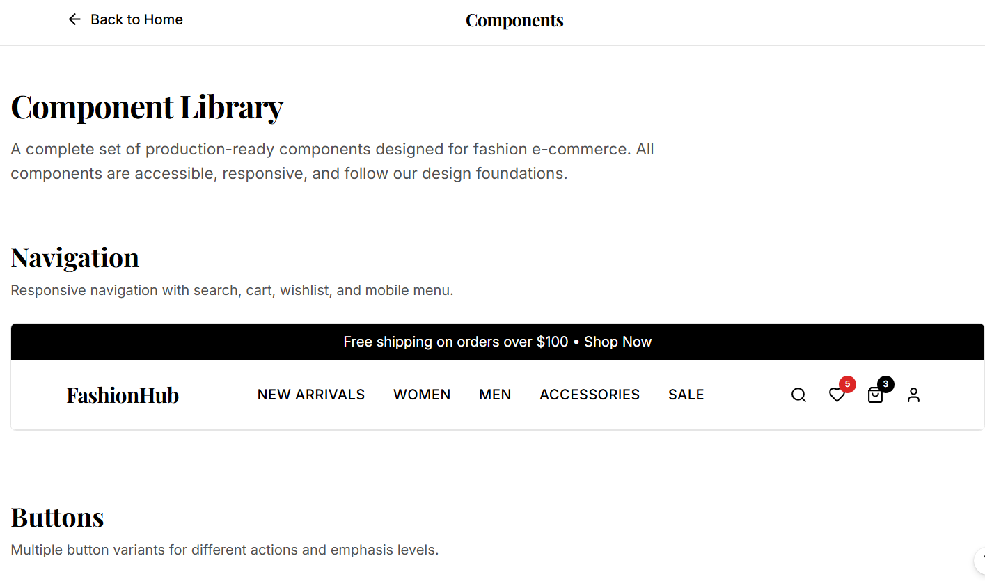
2. Components Library
The Components Library contains reusable UI components designed for fashion e-commerce experiences.
Navigation Component
Features:
- Product category navigation
- Search functionality
- Wishlist support
- Shopping cart integration
- User account access
- Mobile responsiveness

Button Components
Different button styles support:
- Primary actions
- Secondary actions
- Outline buttons
- Promotional actions
- Call-to-action sections

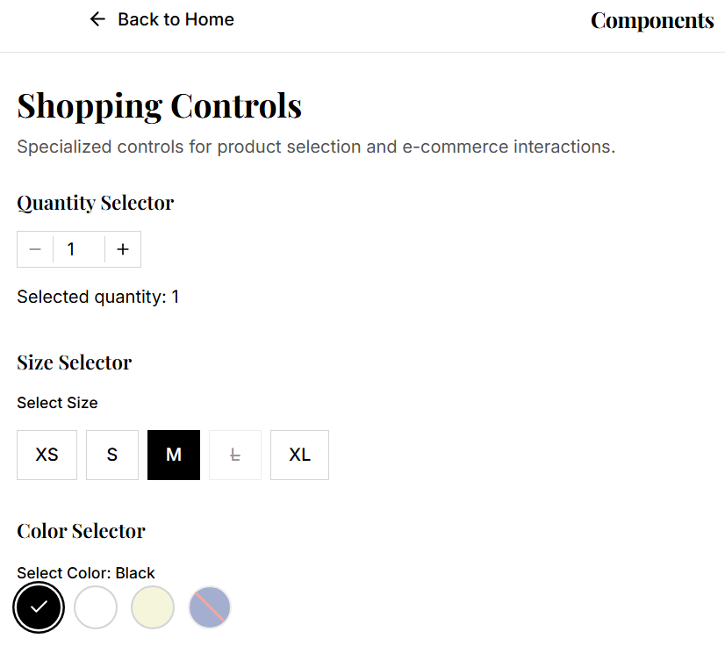
Shopping Controls
Interactive shopping components include:
Quantity Selector
Allows users to increase or decrease product quantities.
Size Selector
Supports multiple clothing sizes such as:
- XS
- S
- M
- L
- XL
Color Selector
Allows customers to choose product colors visually.
Product Cards
FashionHub provides customizable product cards featuring:
- Product images
- Product categories
- Pricing information
- Discount labels
- Wishlist icons
- Sale indicators
These components are optimized for fashion retail experiences.
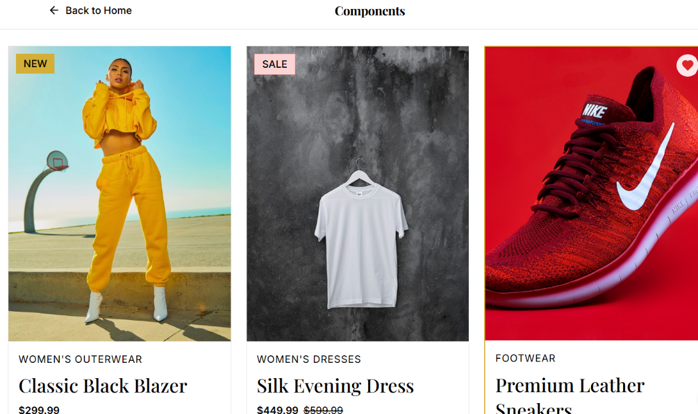

3. Design Tokens
Design tokens act as the single source of truth for design decisions.
Supported Formats
JSON Format
Used for:
- Design tools
- Automation workflows
- Cross-platform integration
SCSS Variables
Used for:
- Sass projects
- Front-end development
- Build pipelines
CSS Variables
Used for:
- Modern web applications
- Dynamic theming
- Responsive design systems

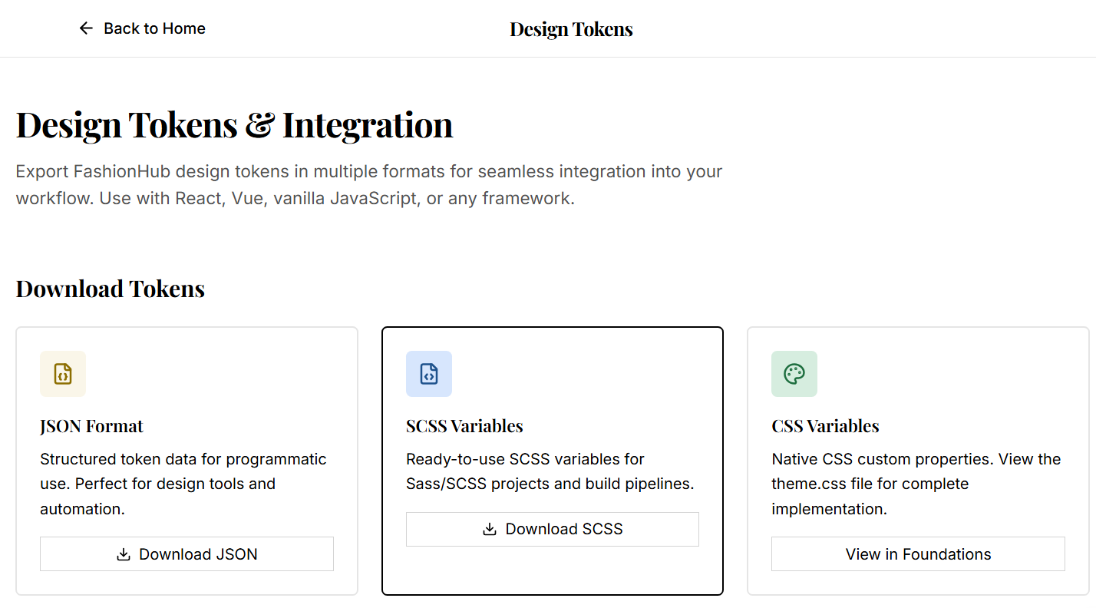

4. Guidelines
The Guidelines section provides best practices for:
- Accessibility
- Typography usage
- Color application
- Layout consistency
- Responsive design
- User experience standards
These guidelines help teams maintain design quality throughout development.

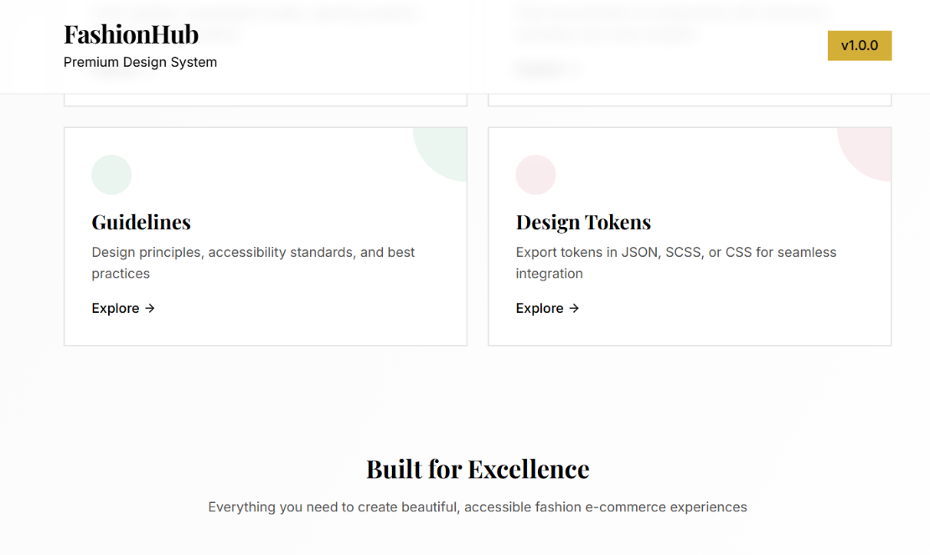
Accessibility
FashionHub follows accessibility-first principles.
Accessibility Features
- WCAG compliant color contrast
- Readable typography hierarchy
- Consistent spacing system
- Keyboard accessibility support
- Responsive layouts
- Inclusive user experiences

Benefits of FashionHub
For Designers
- Faster design workflows
- Consistent visual language
- Reusable design assets
- Improved collaboration

For Developers
- Ready-to-use components
- Standardized design tokens
- Faster implementation
- Easier maintenance

For Businesses
- Strong brand consistency
- Reduced development cost
- Faster product delivery
- Better customer experience

Conclusion
FashionHub is a comprehensive premium design system built for modern fashion e-commerce platforms. By combining design foundations, reusable components, design tokens, and accessibility guidelines, it helps teams create elegant, scalable, and consistent digital experiences while improving efficiency across both design and development workflows.

